eBook / eRead on iPad Instructions
- Launch Safari on your iPad and go to the address for your school
  - Cobb Elementary - https://h100000058.education.scholastic.com/
  - Cobb Middle – https://h100004008.education.scholastic.com/
  - Cobb High - https://h100003989.education.scholastic.com/

- First login to HMH Central. Once you are logged in, press the share icon (folder with arrow going upwards) and then press “Add to Home Screen”
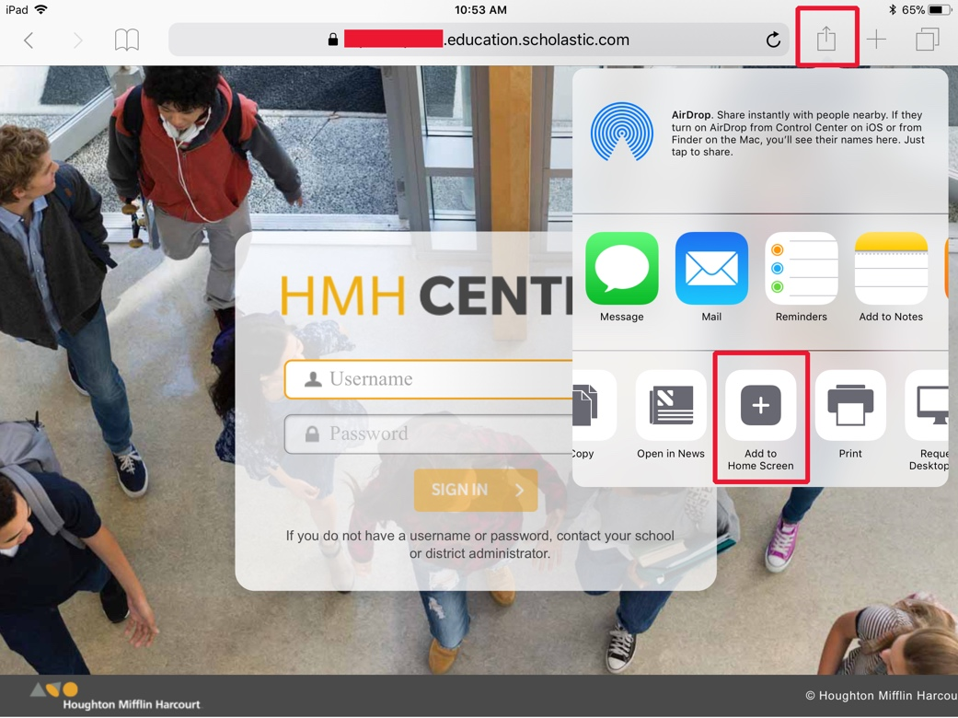

- Press “Add”
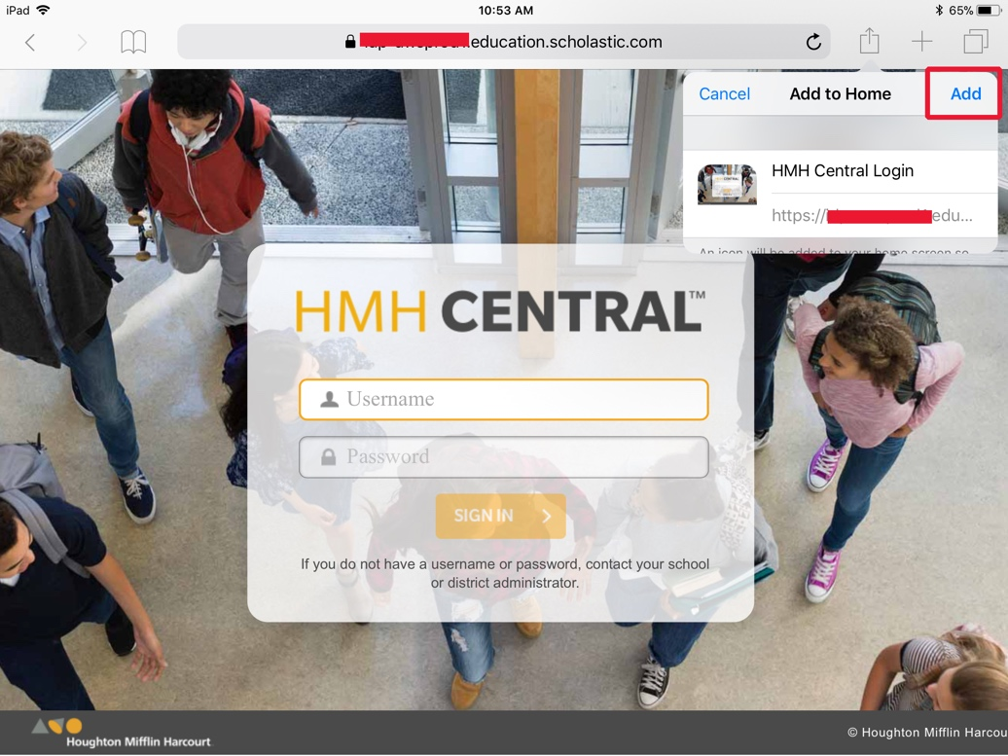

- There will be a shortcut on your Home Screen, open the shortcut and log on HMH Central
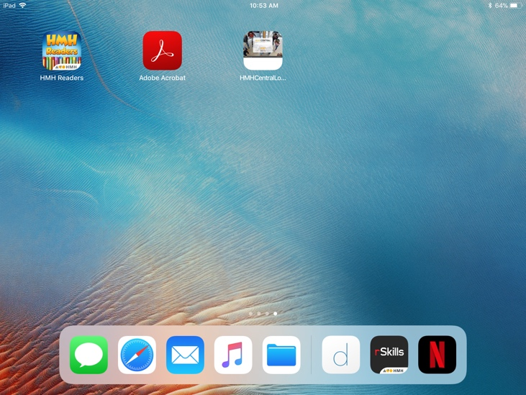
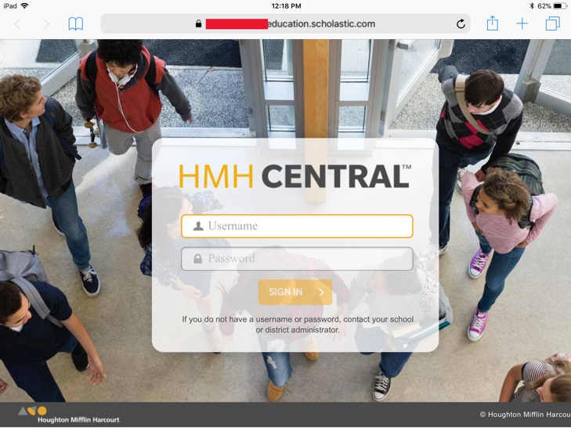

- Select S44 or R180 and select eBook Library (S44) or eReads (R180)

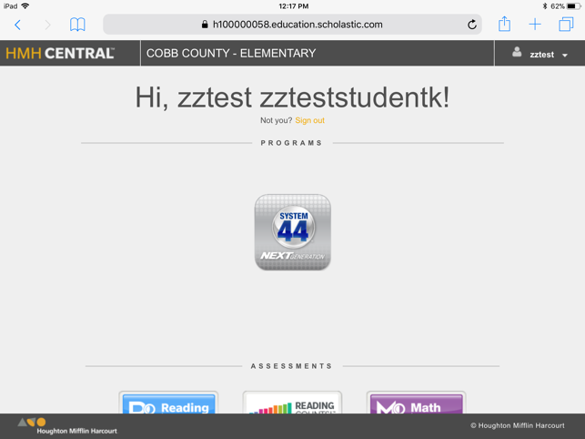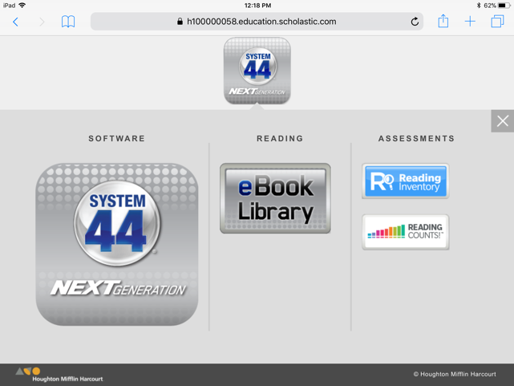

- The student can now read the book and use the speaker icon for Read Aloud.

